SKYE Club Overview

What is it?

The Skills and Knowledge for Youth Economic Empowerment (SKYE) Club emerging project model is an integrated approach to support disadvantaged female and male youth develop the skills, behaviors, and attitudes necessary to obtain sustainable livelihoods and participate constructively in their communities. This is achieved through group based training and support services.
Box 1: Working Definition of Sustainable Livelihoods
A sustainable livelihood means having sufficient income and/ or resources to sustain a productive and fulfilling life.

What are the issues that the SKYE Club model was developed to address?
Entering the labour force is a critical life transition point for youth; however, in many of the communities where World Vision (WV) works, the lives of young people are severely affected by lack of employment opportunities. This is often further compounded by few prospects for engagement in meaningful activities and a limited sense of belonging or connection to their community. For these young people, one-dimensional, simple solutions do not work. Rather, there is a need for multi-dimensional programs that target the principal causes perpetuating disadvantage.

Young people require a diverse range of support mechanisms to foster the individual competencies necessary for participation in social, civic, and economic life. Evidence suggests that economic strengthening interventions (such as vocational training, business development training, and savings groups) which target vulnerable youth should be applied as part of an integrated approach, layered into projects that cultivate their social and emotional skills and abilities.

The SKYE Club model is a youth-focused economic development model that has been co-developed by WV

and NHF to address these needs. The SKYE Club model is an iteration of the IMPACT Club model which was developed by NHF for adolescents (aged 12-17 years).

The SKYE Club approach to engaging youth
The SKYE Club model is designed to address the livelihood needs and aspirations of young people while also addressing critical community development challenges. The SKYE Club model achieves this through two key interventions:

1) SKYE Club Meetings: SKYE Clubs are groups of young adults who meet weekly to have fun, learn, and serve their communities together. A SKYE Club is typically made up of approximately 10-25 youth (aged 18-26) who gather once a week for two to three hours. The clubs are led by volunteer SKYE Club Leaders, who are selected from the community. These Leaders use a curriculum based on experiential learning methodologies to help the youth in the club cultivate competencies in the areas of active citizenship, leadership, employability and entrepreneurship. World Vision supports this activity by hiring a staff member known as a SKYE Club Facilitator. The role of the SKYE Club Facilitator is to recruit, train, coach and support the volunteer SKYE Club Leaders as they lead weekly meetings and help the youth in their clubs to develop.

2) Community Service-Learning Projects: At meetings, SKYE Clubs work together to identify community problems and market opportunities, and then to plan and implement community service-learning and social entrepreneurship-learning projects in response. Youth undertake three to four projects each year, and each project is increasingly complex, delves deeper into community issues, and elicits greater leadership, project management skills, and business development savvy. These projects are SKYE Club’s main learning tool and serve multiple purposes:
- bringing social change to the community;
- applying skills learnt in meetings to consolidate new behaviors and life-skills; and
- developing new ideas to create livelihood opportunities.

The SKYE Club model draws upon experiential learning methodologies and is founded in the principles of positive youth development (see Box 2)
Box 2: Principles of Positive Youth Development
The University of Minnesota has identified eight critical elements of programs that successfully promote positive youth development. Such programs:
- are physically and emotionally safe;
- give youth a sense of belonging and ownership
- foster self-worth;
- allow youth to discover their 'self' (identity, interests, and strengths);
- foster high quality and supportive relations with peers and adults;
- help youth recognize conflicting values and develop their own;
- cultivate the development of new skills; and
- promote fun and expand young people’s capacity to enjoy life and know that success is possible.
Designed to run on an 18-month cycle, the SKYE Club program provides practical and customised support for groups of youth. The model’s curriculum has four learning pillars: active citizenship, employability, social entrepreneurship and leadership.

Through this curriculum SKYE Club members develop a set of five core competencies and 6 foundational values, aimed at fostering the individual competencies in young people necessary for participation in social, civic, and economic life.

The SKYE Club curriculum is also flexible, providing optional modules on agri-business, tourism and social enterprise development, allowing youth to develop skills, knowledge and abilities that effectively respond to market opportunities.

The learning pillars and core competencies are presented in the SKYE Club Learning Structure (page 3).

When would this model be used?
SKYE Clubs are used in relatively stable urban or rural contexts where few opportunities exist to become economically or civically engaged.
The SKYE Club model can be adapted for and applied in communities that have the following characteristics:
- There is a large youth population in the community
- There are limited opportunities for youth to engage in fun or meaningful activities such as sports clubs or volunteer groups
- There are limited opportunities for youth to gain important life and work skills, or practical work experience
- There are limited opportunities for employment in the community
- Many young people are migrating to urban areas or other countries to find employment
- There is evidence that few youth in the area are going on to further education after school
- There is evidence that youth in the area are engaging in risky behaviors such as stealing, violence, gangs, drugs, sex work etc.
- There are structural barriers that prevent women from engaging in community and/or livelihood activities.
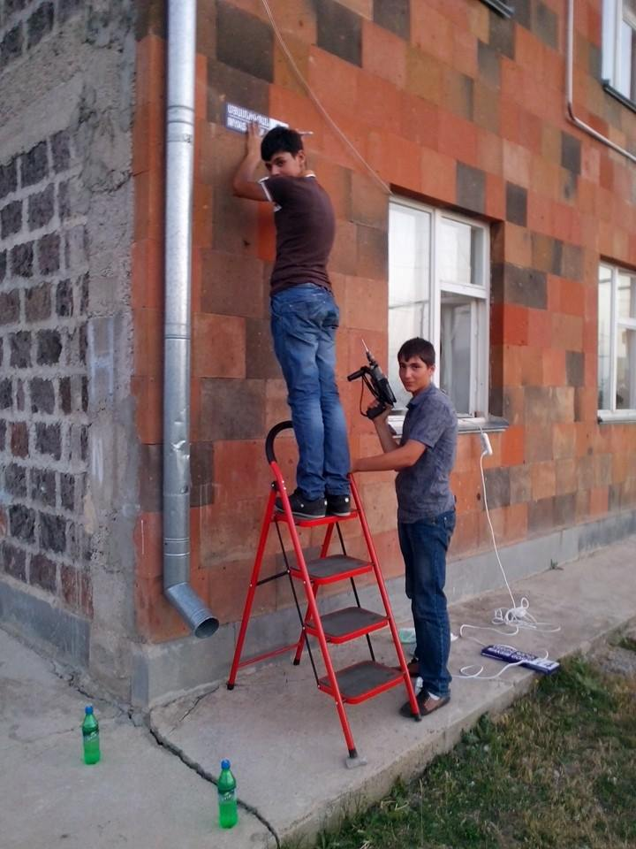
1. SKYE Club members implementing a community service-learning project
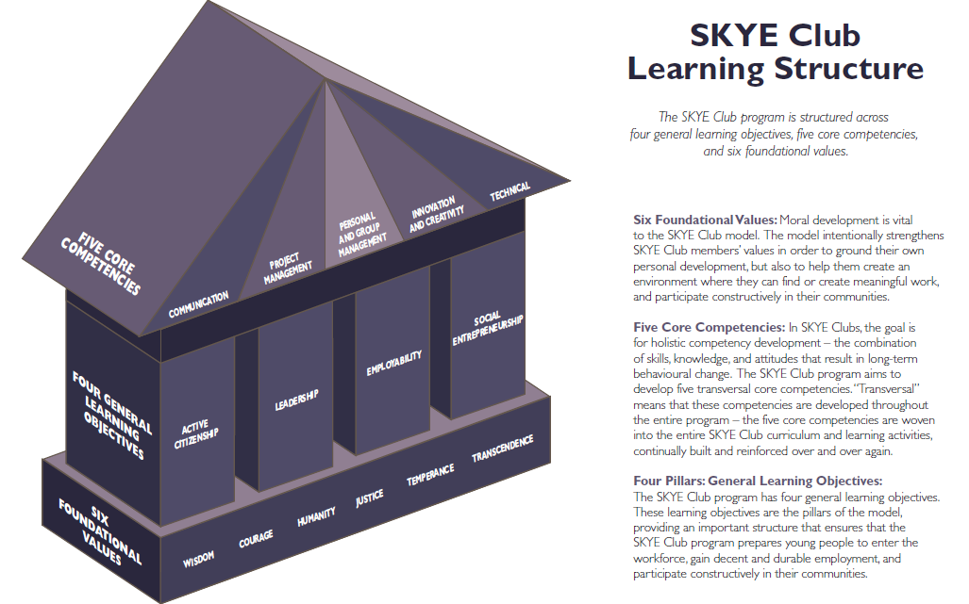

Who is the primary target group?
SKYE Clubs are aimed at youth (aged 18 to 26 years) who are unemployed or underemployed, who have low educational attainment but are interested and motivated to learn new skills and contribute meaningfully to their community.

What are the expected benefits or impacts of this model?
The key expected outcomes for SKYE Clubs include:
- Youth have an improved positive self-concept and future orientation.
- Youth learn and demonstrate critical life and work-readiness skills.
- Youth learn skills and capabilities around leadership and community contribution.
- Youth gain a deeper understanding of community issues and work towards designing evidence-based solutions.
- Youth have an improved likelihood of transitioning to further education and training.
- Youth increase knowledge of the local market and understanding of market dynamics.
- Youth are equipped with the knowledge, skills, experience and networks to find and sustain employment or start their own business.
- Improved social capital and future orientation across community.

What are the resource requirements?

Project length
It is recommended that WV commit to supporting the project for four to five years. After that period, the SKYE Clubs should be self-sustaining and be able to continue the work without any support from WV.

Financial resources
The total cost of an SKYE Club project varies considerably from context to context. Costs are also dependent on the number of SKYE Clubs receiving support within an area. It is estimated World Vision will need to commit between US$200,000 and US$300,000 to the project over a five year period with approximately 15 SKYE Clubs being supported during each 18 month training cycle.

It is expected that a SKYE Club project will directly benefit at least 1,125 youth across the life of a four year project. It is anticipated that the cost per a beneficiary is approximately $270 USD.

Human/technical:
Staffing
The SKYE Club model is not resource intensive nor does it require a high level of technical expertise from WV. A WV Development Facilitator is capable of supervising five SKYE Clubs, requiring only two hours of the Development Facilitators working day. One ADP with 10-15 SKYE Clubs would require one full-time or two part-time Development Facilitators dedicated to the project.

Training and Resources
It is critical that staff supporting and overseeing the implementation of SKYE Clubs are trained in the model, curriculum and associated resources. There are two required trainings for SKYE Club project teams:
- Four day training tailored for WV project staff to introduce the SKYE Club model.
- Six day training for WV project staff and volunteer SKYE Club Leaders.

Optional trainings include:
- Six day Training of Trainers, equipping WV staff to train deliver both required trainings on the model.
- Four day curriculum development workshops that build the capacity of WV staff and volunteers to adapt existing and develop new models to suit the local context.

WV has produced a SKYE Club Project Model Guidance Document and SKYE Club Handbook to provide support to project teams beyond the trainings. The Handbook, in particular, provides detailed guidance on adapting and implementing an SKYE Club project.

Context considerations
The SKYE Club model is a flexible approach and can be adapted to both urban and rural contexts. As with other project models, the skills, knowledge and commitment of the WV team and the community partners are the most critical determinants of success. The SKYE Club model is most likely to be effective with the following conditions:
- The area has stable community structures to partner with such as schools, churches, and community-based organizations
- The geographical area is small enough to ensure that SKYE Club members are willing and able to participate in the club on a weekly basis
- There are youth or adults in the community willing to volunteer their time to be SKYE Club Leaders
- There is no active conflict in the area
- There is a clear and demonstrable interest from youth in the community to participate in a youth-club.
- Economic Development and Education and Life Skills is a priority for the community, local government and WV

Is the SKYE Club model World Vision endorsed?

WV Australia’s Social Entrepreneurship and Economic Development (SEED) Unit is currently piloting the SKYE Club model, testing it as a cost-effective, scalable and replicable approach to youth livelihood programming.

The SKYE Club model has its origins in the IMPACT Club model designed for adolescents aged 12-17 years. SEED Unit has partnered with NHF to innovate, adapt and refine the SKYE Club model for WV. Working through an economic development lens, SEED will ensure that the program and associated curriculum is cognisant of the local economic context and that youth will have greater access to markets and increased chances of finding employment.

The piloting of the approach has been endorsed by the Child Well-being and Rights Community of Practice, the Resilience and Livelihoods Community of Practice, the Education and Life Skills Community of Practice, and the Global Centre for Economic Development.
For more information contact:
Kate Williams
Economic Development Consultant – Youth Pathways
Global Champion – IMPACT Clubs and SKYE Clubs Project Models
Social Entrepreneurship & Economic Development (SEED) Unit
World Vision Australia
Kate.Williams@worldvision.com.au

Chris Rowlands
Manager
Social Entrepreneurship & Economic Development (SEED) Unit
World Vision Australia
Chris.Rowlands@worldvision.com.au

Over 35% of the population is aged between 15-25 years.

