IMPACT Lessons Learnt

Yerevan Area Development Program
Gevorg Jenderedjian - spring 2015

Acknowledgment

During one year IMPACT project model was piloted in Armenia specifically in Yerevan and Talin. In the course of the pilot we had to understand the context differences between Armenia and Romania. As you might know LEAP 3 offers to be very intentional about evidence building and currently WV Armenian Branch is on a stage of collecting evidence regarding IMPACT project model. While piloting the model we faced many problems and uncertainties, which got their solutions in result of good team work, namely, Kate Williams ED consultant, Liana Sargsyan Youth Program Manager, Jock Noble ED Hub Lead MEER, Marina Hovhannisyan YADP Manager Gayane Simonyan Talin Youth Coordinator.

Why you would be interested to read this?

As popular saying states: “People learn on their mistakes, while the smart ones learn on the others’ mistakes.”
This article will help you to overcome issues that you might come across, brings to your attentions practiced solutions. The article is a short handout of tips that will raise the effectiveness of the project.

Be a problem seeker.

Running clubs in an environment where people have to think about their daily piece of bread is not an easy task, however it is possible to have an excellent operating club in such kind of setting.
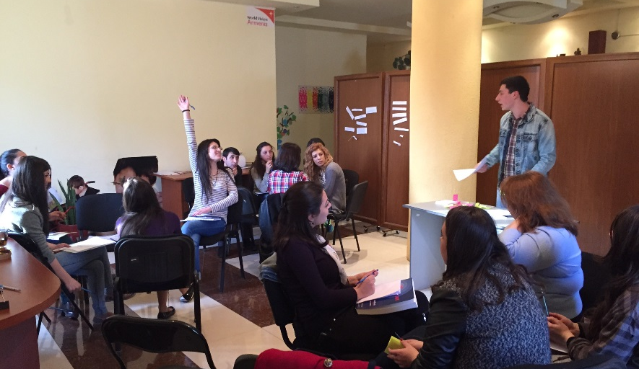
There are three types of people regarding their approach to problems. Problem avoiders – people who try to avoid the problem even when the problem is obvious. Problem solvers – take measures to solve the problem when it is obvious. And finally problem seekers – people who tend to see and research in order to find and solve the problem. Usually people differ from one type to another depending on many factors, where the determining factor is experience and knowledge.
SKYE club members are testing their project “answer in a minute” to understand what could go wrong in reality. Yerevan, Armenia.

New IMPACT leaders lack experience and knowledge to admit the existence of the problem, moreover, even when problems are obvious they try to avoid them. This will increase the drop rate of leaders and the result will be poor operating clubs.

Example
The initial number of club members were 32 at N127 School. On every consecutive visit to the club, the number of participants declined, however leader was considering it normal, moreover, relating it to other events like excursions, bad weather, etc. The leaders were reluctant to identify the real reason of poor participation. They refused to admit that decreasing number of participants was an indicator of the problem.

Suggestion
Be a role model for the leaders, be supportive, encourage them in identifying the problems and be fully involved in solving them, always keep in mind “if something can go wrong, then most probably it will go wrong” so do not hesitate to take actions and seek for problems.
Know the project module perfectly.
Though after IMPACT Initiation training leaders will be able to describe, facilitate, lead and evaluate the performance of IMPACT club, they will experience gaps in knowledge when practically leading the clubs, facilitating the evaluation meeting and projects. Apparently local coach is the one that would assist club leaders with filling gaps in knowledge.
Refreshing meeting for IMPACT and SKYE club leaders. Yerevan, Armenia.

The most probable gaps in knowledge are as follows:
What is debriefing, the purpose of it and how to facilitate the process appropriately?
What is the purpose of Evaluation meeting, how to construct their educational program?
When the club should start the first project and when it should start the next one?
When members are preparing the project proposal?
Can leaders change the order of the modules?
What documentations should the leaders fill in? Etc.

Suggestions
Be ahead of your clubs by 3-4 meetings, and in case of questions don’t hesitate to approach responsible program manager. During the first week ask leaders’ questions that will help you to identify their gaps in knowledge, and at the end of the week hold a refreshing Training. Also it is a good idea to have printed templates of all the clubs’ documents and distributed them among the leaders, also proved them with a handout that will inform them about the purpose of the documents and deadlines.
Above you can find the most used documents in Armenian, but take into account that there are other club related documents that are not included in the list.

Where to look for good leaders and how to keep them motivated?

You might want to look for good and motivated leaders, as with their involvement IMPACT clubs will operate well and you get rid of many routine problems. As a matter of fact good leaders might be considered as the most important precondition for a successful club. The other important point is to keep them motivated.

Suggestion
As a matter of fact it is complicated to outline any specific place where a good leader can be found, the question is what resources ADP already has to ease the search for leaders. The ADP resources include but is not limited to; parent councils, school teachers, ADP active youth, social workers, student councils, RC children caregivers, employment centers. But, don’t recruit the leaders blindly, speaking with them personally. School principals may assign their teachers to participate the training and run the clubs, but usually he might not know what IMPACT training is about and, moreover, what obligations he has. To this end it is advised to hold personal interviews to understand whether or not the candidate is really interested to take the new role. You might discover that many of them are not quiet interested to stay with the club for a long time. Together with the benefits of running the clubs take care to explain the leaders the difficulties of being club leader too. For instance, from the very beginning they might want to know that to run a club is time consuming process, they have to come to the club meetings well prepared, participate monthly leaders’ meetings, etc. When presenting the benefits of the clubs to leaders, schools or other stakeholders it might be useful to use this word file attached above, that outlines the benefits of the IMPACT clubs for stakeholders.
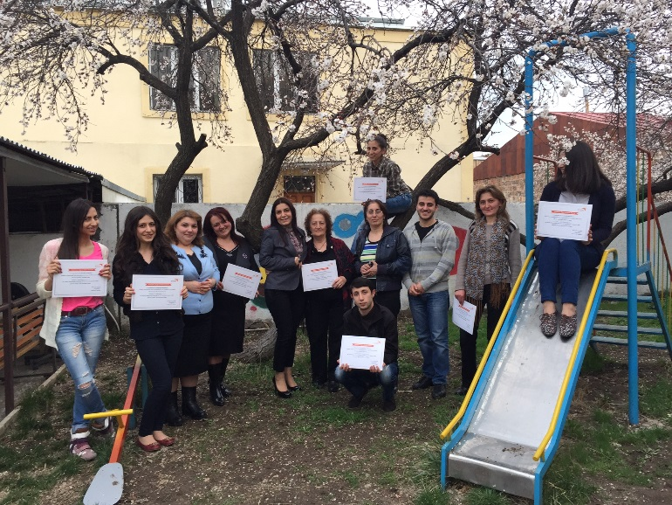
To keep them motivated be intensive about monthly meetings with all leaders, where each club presents its monthly activities, success, challenges, concerns, etc. Before each monthly meeting develop an agenda and distribute them among the leaders. You can have small aside events before the meetings as birthday celebration. You can also present appreciation awards for good performance as well as have an outdoor gatherings. Mention their accomplishments on a Facebook page, or ADP journals (if available). It is also recommended to establish friendly relations, ask them for a help if needed, call them on birthdays
Club leaders receive appreciation awards from YADP Manager. Yerevan, Armenia.

Opening and facilitating clubs.
When prepared well, you do well. It is highly suggested that leaders learn about the clubs’ settings as much as possible and clearly know about their steps for the near future.

Suggestion
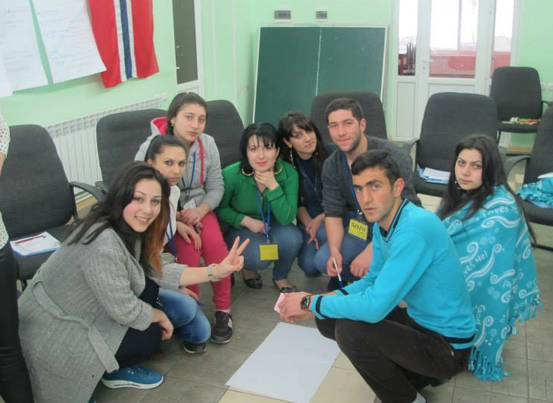
To this end developing detailed implementation plan and risk assessment might be very useful. As for developing these documents leaders have to learn about the settings of the clubs as much as possible. This will help them to understand what measures should be taken to open the clubs, and carry out the risk assessment of their actions. Having both documents well developed makes it sure that the club leaders to know the club operating environment and are ready to take measures if something goes wrong. As well as the documents will help local coach and club leader to communicate easily and to agree on actions. Below you might find samples of DIP and Risk assessment of N103 School in Yerevan ADP.
IMPACT initiation training. new leaders are introduced action plan and risk assessment concepts. Lori Marz, Armenia.

