IMPACT Club Overview

What is it?

The IMPACT Club emerging project model is an integrated approach to adolescent engagement that fosters the skills, behaviors, and attitudes necessary for participation in social, civic, and economic life. The IMPACT Club model encourages the development of confident, self-aware and resilient young people who contribute positively to their communities via youth led community projects. This is facilitated through group based training and support services.

What are the issues that the IMPACT Club model was developed to address?
In many of the communities where World Vision (WV) works, the lives of young people are severely affected by lack of access to education, few prospects for engagement in meaningful activities, and a limited sense of belonging or contribution to their community. These young people require a diverse range of support mechanisms to foster the individual competencies necessary for safe and successful transitions into adulthood.

Adolescents require multi-dimensional programs that improve positive self-identity, and cultivate critical life and work readiness skills. Evidence shows that there is a clear connection between holistic programs that foster the development of these skills and positive life outcomes, including “labour-market outcomes, family life, conflict resolution, civic engagement, and health behaviours.”

The IMPACT Club model was developed in Romania by New Horizons Foundation (NHF) to address these needs.

The IMPACT Club approach to engaging youth
The IMPACT Club model is designed to equip adolescents for safe and successful transitions to adulthood, while also preparing them to become leaders of constructive social

change in their communities. The model achieves this through two key interventions:

- IMPACT Club Meetings: IMPACT Clubs are groups of adolescents who meet weekly to have fun, learn, and serve their communities together. An IMPACT Club is typically made up of approximately 10-25 adolescents (age 12-17) who gather once a week for two to three hours. The Clubs are led by volunteer IMPACT Club Leaders who are selected from the community. These Leaders use a curriculum based on experiential learning methodologies to help the adolescents in the club cultivate competencies in the areas of active citizenship, leadership, employability and entrepreneurship. WV supports this activity by hiring a staff member known as an IMPACT Club Facilitator. The role of the IMPACT Club Facilitator is to recruit, train, coach and support the volunteer IMPACT Club Leaders as they lead weekly meetings and help the adolescents in their clubs to develop.

- Community Service-Learning Projects: At meetings, IMPACT Club members work together to identify community problems, brainstorm possible solutions, identify community resources, and plan and implement community service-learning projects. Adolescents undertake two to three projects each year, and each project is increasingly complex, delves deeper into community issues, and elicits greater leadership, project management and business development skills. These projects are the IMPACT Club project model’s main learning tool and serve multiple purposes, including:
- bringing social change to the community; and
- applying skills learned in meetings to consolidate new behaviors and life-skills.

IMPACT Club model draws upon experiential learning methodologies and is founded in the principles of positive youth development (see Box 1).
The model’s multi-year curriculum has four learning pillars: active citizenship, employability, social entrepreneurship and leadership.
Box 1: Principles of Positive Youth Development
The University of Minnesota has identified eight critical elements of programs that successfully promote positive youth development. Such programs:
- are physically and emotionally safe;
- give youth a sense of belonging and ownership
- foster self-worth;
- allow youth to discover their 'self' (identity, interests, and strengths);
- foster high quality and supportive relations with peers and adults;
- help youth recognize conflicting values and develop their own;
- cultivate the development of new skills; and
- promote fun and expand young people’s capacity to enjoy life and know that success is possible.

Through this curriculum IMPACT Club members develop a set of five core competencies and six foundational values, aimed at fostering the individual competencies in young people necessary for participation in social, civic, and economic life.

The IMPACT Club curriculum is also flexible, offering optional modules, for example Faith and Spirituality, Health and Sexual Education, and works in various faith-based or secular contexts. In this way, the IMPACT Club model can be used in a variety of environments, and refocused to address specific issues affecting young people in the local context.

The learning pillars, core competencies and values are presented in the IMPACT Club Learning Structure (see page 3).

What are the main features of the model?
- Multi-dimensional approach to adolescent engagement
- Multi-year curriculum based on experiential education methodologies
- Founded on the principles of positive youth development
- Groups are adolescent led, self-managed and independent (thus sustainable)
- Group size of 10 to 25 members
- Groups are facilitated by two trained volunteer IMPACT Club Leaders
- A World Vision Development Facilitator can support five to fifteen IMPACT Clubs
- Low-cost

When would this model be used?
IMPACT Clubs are used in relatively stable urban or rural contexts where few opportunities exist to become engaged in meaningful activities including economic, social, civic and spiritual. The IMPACT Club model can be adapted for and applied in communities that have the following characteristics:
- There are high numbers of adolescents in the community
- Young people have limited opportunities to engage in out-of-school activities
- Adolescents have limited opportunities to gain important life and work skills
- There is evidence that few adolescents and youth in the area are going on to work or further education after school
- There is evidence that adolescents and youth in the area are engaging in risky behaviors such as stealing, violence, gangs, drugs, sex work etc.
- There are structural barriers that affect girls’ and women’s ability to equitably engage in community and/or livelihood activities

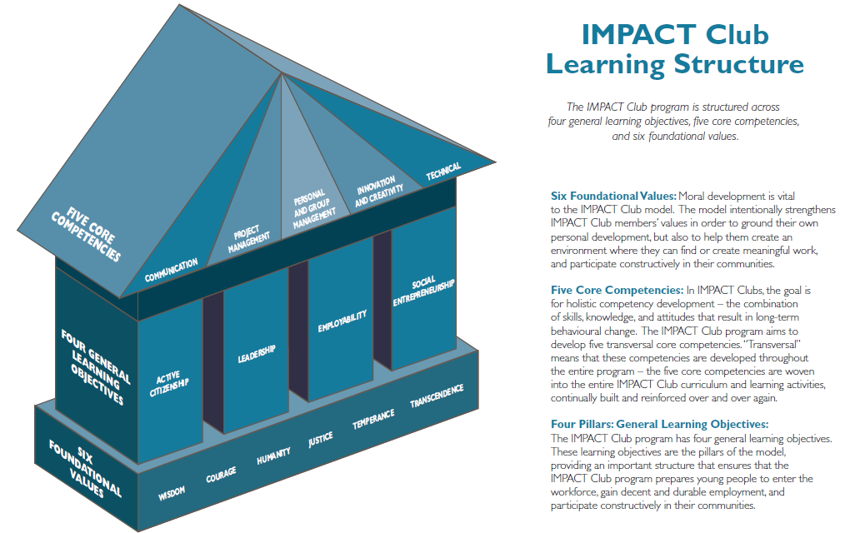

Who is the primary target group?
IMPACT Clubs are aimed at adolescents (aged 12 to 17 years) who are in school and are interested and motivated to learn new skills and contribute meaningfully to their community.

What are the expected benefits or impacts of this model?
The key expected outcomes for IMPACT Clubs include:
- Adolescents learn and demonstrate critical life and work-readiness skills.
- Adolescents learn skills and capabilities around leadership and community contribution.
- Adolescents gain a deeper understanding of community issues and work towards designing evidence-based solutions.
- Adolescents have an improved likelihood of completing their basic education and transitioning to further education, training, and employment.
- Adolescents have an improved positive self-concept and future orientation.
- Improved social capital and future orientation across community

What are the resource requirements?

Project length
It is recommended that WV commit to supporting the project for three to four years. After that period, the IMPACT Clubs should be self-sustaining and be able to continue the work without any support from WV.

Financial resources
The total cost of an IMPACT Club project varies considerably from context to context. Costs are also dependent on the number of IMPACT Clubs receiving support within an area. It is estimated WV will need to commit between US$150,000 and US$250,000 to the project over a four year period with approximately 15 IMPACT Clubs being supported.

Human/technical:
Staffing
The IMPACT Club model is not resource intensive nor does it require a high level of technical expertise from WV. A WV Development Facilitator is capable of supervising five IMPACT Clubs, requiring only two hours of the Development Facilitators working day. One ADP with 10-15 IMPACT Clubs would require one full-time or two part-time Development Facilitators dedicated to the project.

Training and Resources
It is critical that staff supporting and overseeing the implementation of IMPACT Clubs are trained in the model, curriculum and associated resources. There are three required trainings for IMPACT Club project teams:
- Four day training tailored for WV project staff to introduce the IMPACT Club model.
- Six day training for WV project staff and volunteer IMPACT Club Leaders.
- Four day ‘refresher training’ for WV project staff and IMPACT Club Leaders. It is suggested that this be included in the project budget for the second year of activities.

Optional trainings include:
- Six day Training of Trainers, equipping WV staff to train deliver both required trainings on the model.
- Four day curriculum development workshops that build the capacity of WV staff and volunteers to adapt existing and develop new modules to suit the local context.

WV has produced an IMPACT Club Project Model Guidance Document and IMPACT Club Handbook to provide support to project teams beyond the trainings. The Handbook, in particular, provides detailed guidance on adapting and implementing an IMPACT Club project.
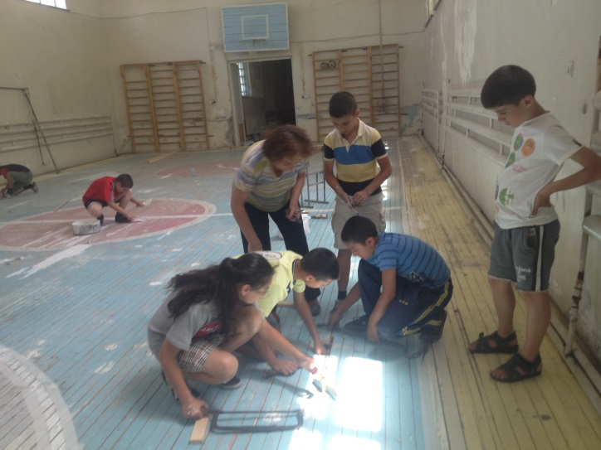
1 IMPACT Club members implementing a community service-learning project in their school.

Context considerations
The IMPACT Club model is a flexible approach and can be adapted to both urban and rural contexts. As with other project models, the skills, knowledge and commitment of the WV team and the community partners are the most critical determinants of success. The IMPACT Club model is most likely to be effective with the following conditions:
- There is clear and demonstrable evidence that adolescents are interested in participating in youth-clubs.
- The area has stable community structures to partner with such as schools, churches and community-based organizations.
- The geographical area is small enough to ensure that IMPACT Club members are willing and able to participate in the club on a weekly basis.
- There are adults in the community willing to volunteer their time to be IMPACT Club Leaders.
- There is no active conflict in the area.
- Economic Development and Education and Life Skills is a priority for the community, local government and WV.

For more information contact:
Kate Williams
Economic Development Consultant – Youth Pathways
Global Champion – IMPACT Clubs and SKYE Clubs Project Models
Social Entrepreneurship & Economic Development (SEED) Unit
World Vision Australia
Kate.Williams@worldvision.com.au

Chris Rowlands
Manager
Social Entrepreneurship & Economic Development (SEED) Unit
World Vision Australia
Chris.Rowlands@worldvision.com.au

Is the IMPACT Club model World Vision endorsed?
World Vision Australia’s Social Entrepreneurship and Economic Development (SEED) Unit is currently piloting the IMPACT Club model, testing it as a cost-effective, scalable and replicable approach to adolescent engagement and work-readiness programming.

The piloting of the approach has been endorsed by the Child Well-being and Rights Community of Practice, the Resilience and Livelihoods Community of Practice, the Education and Life Skills Community of Practice, and the Global Center for Economic Development.

McNeil, B, Reeder, N, Rich, J. (2012) A framework of outcomes for young people, The Young Foundation, London, UK
Over 35% of the population is aged between 12-17 years.

