Adolescent and Youth Development
Programming Guidance

DRAFT 03-23-15

Contents

Contents 2
Purpose of this guidance 3
Introduction 4
Age ranges for WV’s adolescent and youth programming 5
Key features of WV’s adolescent and youth programming 6
Positive youth development 6
Essential elements for WV’s adolescent and youth programming 9
Special priority on the most vulnerable children 10
Root cause analysis informing WV’s adolescent and youth programming 12
Available project models for WV’s adolescent and youth programming 13
Monitoring and evaluation for adolescent and youth programming 14
Facilitator competencies for WV’s adolescent and youth programming 16
Working with local partners in WV’s adolescent and youth programming 17
Collective spaces in WV’s adolescent and youth programming 18
Sustaining adolescent and youth programming 19
Local level advocacy in adolescent and youth programming 19
Sponsorship and adolescent and youth programming 21
Appendix A – Resources 22
Appendix B – Competency for working with young people 23

Purpose of this guidance
The purpose of this document is to provide guidance, recommended approaches and to highlight critical considerations for national offices designing and planning programming for adolescents and youth.
Working with adolescents and youth requires some unique skills – particularly in facilitation and understanding. This guidance will help World Vision (WV) staff at all levels to be effective as they support young people.
It is essential reading for staff who are involved in:
- Leading, supporting or providing technical input for adolescent and youth programming
- Designing technical approaches and programming for adolescents and youth.
This guidance can be used by national offices as they design technical approaches – either for programmes with a sole focus on adolescent and youth, or where they are one component of a multi-faceted technical approach. For example, a child protection technical approach may include a component which focuses on strengthening adolescent coping and resilience skills, while other components may be focused on strengthening different aspects of the child protection system.
This guidance provides an overview of recommended project models for adolescent and youth programming. It also provides essential, higher-level guidance for incorporating adolescent and youth programming into any other WV programming. It can also assess existing adolescent and youth programming to support increased impact and sustainability.
Using this guidance will allow national, zonal and local level staff to integrate and adapt project models and other programming options in ways appropriate for each context, which will bring maximum and sustainable benefits for young people.
Please note, the term young people will be used throughout this guidance document to refer to both adolescents and youth.
A list of key resources is provided in Appendix A.

Questions for consideration:
- Who needs to know about this guidance within your national office?
- How will they access it?
- How will you ensure this guidance is shared with the right people?
- How can you ensure that all staff put this guidance into practice?

Introduction
Today there are an estimated 1.8 billion young people (aged 10 to 24 years old), worldwide. Approximately 90% of them live in developing countries where they make up a large proportion of the population. Adolescents and youth thus make up a significant proportion of the population where WV works. In addition, within the lifetime of WV development programmes, children registered for sponsorship will become adolescents and then adults – becoming parents of the next generation.
Why is it important for WV national offices to consider focusing on adolescents and youth in their strategies, technical approaches, and programming?
- The adolescent stage is a critical period of development. During adolescence young people experience complex transitions and significant physical, spiritual, emotional and mental developmental milestones.
- Previously, scientists believed that brain development slowed down after early childhood but recent studies show that around age 11, there is an explosion of new brain activity that affects emotional, physical and mental abilities. In addition, ‘if early investment in disadvantaged children is not followed up by later investment, its effect at later ages is lessened.’
- The Convention on the Rights of the Child legally affirms young peoples’ rights to freely express their opinions and be involved in decision-making and actions that affect themselves and their communities. Young people also play a role in their own emotional, physical, spiritual and mental development. WV has an important role to help them achieve their full potential by helping them to express themselves confidently and effectively, enabling them to be agents of change.
- Significant gains have been made in reducing child morbidity and mortality for children under 5, but these gains can be lost if there is no intentional focus on this second decade of life.
- WV places a special priority and focus on the most vulnerable children. In many contexts, violence, exploitation, abuse and neglect have the biggest effect on adolescents.
- Approximately 60% of WV’s programme areas face the risk of conflicts and disasters. WV can work with young people - strengthening relationships, encouraging their assets and building resilience.
Whether rural or urban, WV’s long-term, community-based approach provides an opportunity to work alongside communities seeking transformation and sustained change. With our efforts, WV seeks to break the cycle of intergenerational poverty. Programming focused on adolescents and youth – the parents of the next generation – is a vital part of this effort and contributes towards WV’s ministry goal:
‘A society that cuts itself off from its youth severs its lifeline; it is condemned to bleed to death.’
Kofi Annan, United Nations Secretary-General
Adolescence: A Time That Matters, UNICEF
‘The sustained well-being of children within families and communities, especially the most vulnerable.’

A unified strategy across sectors and themes:
WV’s long-term presence in our development programmes also enables us to think about how we can make the most of all the different programming implemented with young people. For example, one programme may have a small Christian Commitment project in one location, a Communications for Development (C4D) project with another group of children in another location, and environmental clubs started in other areas.
Consider how WV staff can plan across sectors and themes at the outset of a programme, building life skills and competencies of young people, maximizing impact, and strengthening local partner capacity to implement to scale:
- Prepare for young people’s participation during the initial steps of the Critical Path:
  - Identify the spaces where adolescents and youth meet, play and socialize – both formal and informal.
  - Identify civic spaces where young people could participate; shaping and influencing decision making.
  - Ensure young people, especially the most vulnerable, have opportunities to participate when child well-being issues are being explored in their communities, so they can inform priorities and planning.
- Explore approaches, recommended project models and other options that build competencies and life skills in young people:
  - Identify local champions who can facilitate local inputs with young people, and explore how we can equip and support them.
  - Ensure that adolescent and youth programming include a core curriculum of essential life skills.
  - Ensure project models or other programming options selected are relevant for the context.
  - Consider how supplemental options (or lego blocks) support established groups of young people.
- Ensure sustainability by organising and partnering for sustained change:
  - Identify local partners with capacity or interest in adolescent and youth programming and support them in establishing and scaling up this work.
  - Establish spaces and networks where young people can participate in civic decision making.

Age ranges for WV’s adolescent and youth programming
There are no universally agreed age ranges for the terms ‘adolescents’ and ‘youth’. However, for consistency and measurement purposes, WV uses the following definitions:
WV defines adolescents as children aged 12 to 18 years of age.
This definition is used in WV’s lifecycle approach and measurement tools for WV’s Child Well-being Target #1.
WV defines youth as young people, aged 15 to 24 years of age.
This definition is used by the United Nations, which uses this definition for statistical purposes
Even within WV’s broad definitions, understanding the developmental needs and the evolving capacities of a specific target age group in a given context is critical for ensuring projects are responsive and successful. For example, a project for girls, 12 to 14 years old, would have very different considerations than a project for young men, 20 to 24 years old.
National offices should seek to assess and define culturally-appropriate age range definitions as they conduct root cause analyses and design technical approaches. In addition, monitoring and evaluation frameworks for technical programmes should separate out indicators using sex and culturally-defined age ranges in their analysis.

Questions for consideration:
- Do your national office staff understand the importance of defining specific age ranges for their projects which fit the cultural context, maturity, capacity and needs of the target groups?
- During monitoring and evaluation, do your staff use appropriate indicators to separate out age, gender, ethnic or other key issues in their analysis?

Key features of WV’s adolescent and youth programming
‘[Adolescent] and youth programming has traditionally been implemented within specific sectors,
including health, education, employment and civic participation. Increasingly, however, [adolescent] and youth development practitioners recommend that sector approaches be broadened to include cross-sector and integrated approaches, and that greater attention be paid to strengthening youth development systems.’
Youth in Development policy, United States Agency for International Development

World Vision’s adolescent and youth programming:
- Builds on a theory of positive youth development (defined in next section)
- Empowers young people to be active agents of change for themselves and their communities
- Recognises the vital role of long-term ‘developmental’ relationships that support young people
- Improves life skills, outcomes and functional literacy for individual young people, and the groups they are involved with
- Works with local partners and champions to build community commitment and ensure sustainability
- Ensures that WV staff, local partners and local champions have the competencies needed to effectively facilitate and work with young people
- Adheres to essential elements to ensure quality implementation
- Leads to young people who have a positive identity, basic skills and the ability to apply life skills as they become productive and healthy citizens and contributors to community and family life
- Affirms young people’s dignity and value and supports them in identifying and pursuing their hopes, dreams and vocation through spiritual nurture
- Catalyses movements of young people as change agents.
This guidance contributes to WV’s broader efforts to ensure children’s meaningful participation in contributing to decision making and taking action on issues affecting their lives. See the resource list in Appendix A for World Vision child participation guidelines and other key resources.

Positive youth development
World Vision’s adolescent and youth programming is based on a theory of positive youth development. This theory is built on our understanding of how young people develop. Children, adolescents, and youth do not develop and grow in isolation. They grow within families, schools, neighborhoods, structures and systems and within a broader cultural, political, historical context, place and time.
In addition, development is not simply a one-way process where adults ‘pour’ into children for them to grow. Rather, young people play a vital role in their own development while also influencing the people around them. Children are individuals, each born with evolving skills, values and competencies. As children interact in relationships with others around them and with the support, opportunities and resources available to them, a dynamic interaction takes place. Each interaction affects the young person’s development in either positive or negative ways.

Positive youth development is a strengths-based approach. It differs from traditional programming in that it does not focus on what is ‘broken’ or undeveloped in young people. Instead it focuses on young people’s strengths, skills and possibilities. It affirms positive outcomes for young people through productive activities and healthy relationships. This approach is very relevant within fragile contexts or programme areas at risk of disaster or conflict, as it focuses on building on the capacities already present.

Figure 1: Dynamic interaction with surroundings promote healthy, productive citizens
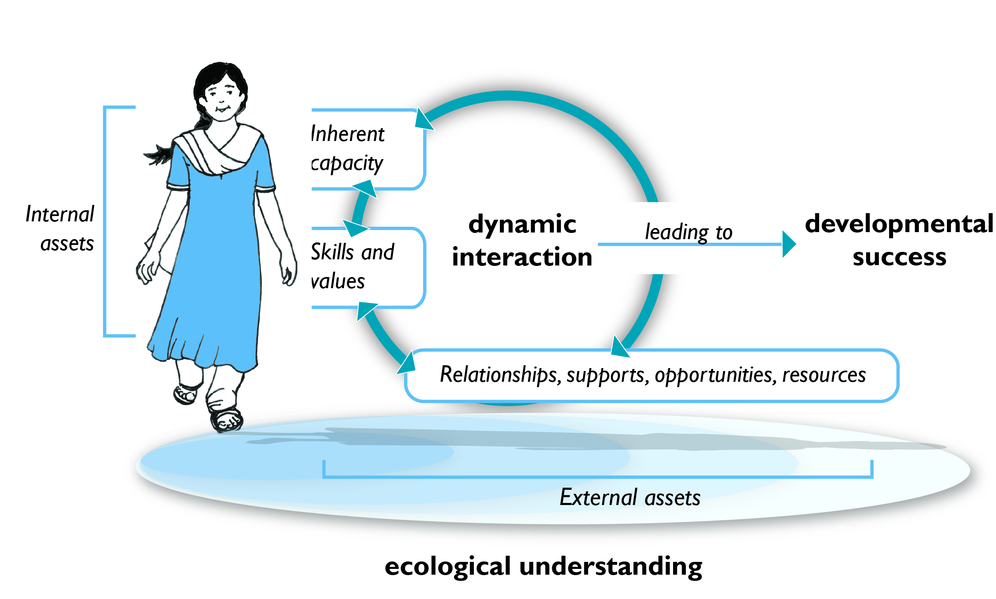

The theory of positive youth development highlights that:
- Changes within the young person’s relationships and contexts will change their development. So programming that builds on existing strengths and addresses weaknesses in a young person's surroundings and relationships will enhance the ‘developmental success’ of young people.
- Young people can take action to change the contexts in which they live. Inputs that actively engage young people are empowering and can also create positive change in the young person’s surroundings and relationships.
As shown in the diagram above, both internal and external assets are critical building blocks of ‘developmental success’. Developmental assets and life skills are overlapping but complementary concepts.
Developmental assets are defined as positive experiences, attitudes, relationships, values, skills, and qualities found in adolescents, peers, families, schools, and communities. Such assets are both internal to the young person, and external - the relationships and contexts that supports young people’s successful development.
Life skills emphasize the competencies that are essential well-being.
- Cognitive skills: Cognitive skills refer to the range of competencies a person uses to obtain, analyze and use information gained through thought, experience, and the senses to build knowledge and guide decisions and actions.
- Emotional or personal skills:
Personal skills refer to the range of competencies required to organize, plan, and accomplish personal affairs, circumstances and ambitions.
- Social or interpersonal skills:
Interpersonal skills refer to the range of competencies required for people to interact effectively with others, both directly and within institutions, through communication, listening, teamwork, and leadership.

Basic skills such as functional literacy, numeracy, financial literacy and the ability to save and access credit, are also important in enabling young people to thrive and be part of breaking the cycle of intergenerational poverty.

WV’s ‘educated for life’ target ensures a focus on functional literacy training when levels are below threshold values. Later sections of this guidance include tools for conducting a root cause analysis, a decision tree and programming options to enable national offices to plan an appropriate and responsive project design. In practice this means that WV wants to ensure that adolescents and youth:
Goals from the Dakar Framework, adopted by the World Education Forum, Dakar, Senegal, 26-28 April 2000 which guide WV’s adolescent and youth programming:
- Ensuring that the learning needs of all young people and adults are met through equitable access to appropriate learning and life skills programmes
- Improving every aspect of the quality of education, and ensuring their excellence so that recognized and measurable learning outcomes are achieved by all, especially in literacy, numeracy and essential life skills.

- Can read well enough to read an article in the newspaper and act on what they have read
- Have math skills that are good enough for young people to be able to prepare a profit and loss statement on whatever economic activity or personal budget is relevant for them
- Can apply reasoning skills to manage their emotions and relationships in ways that enhance their productivity and their fulfillment.

Questions for consideration:
- How much do your staff understand about positive youth development?
- Can you brainstorm internal and external assets for your context and identify weak points?
- Are your staff equipped to facilitate adolescents and youth in a way that builds up their assets?
- If you are working in a high risk disaster or conflict context, how can you plan to ensure that adolescents and youth can be empowered to develop solutions for their current situation?

Essential elements for WV’s adolescent and youth programming
Surprisingly, not all projects targeting adolescents and youth are effective. In fact, approaches found really effective in one study may have little or no impact when replicated elsewhere. However, a consensus is emerging from research about what critical features are found in high-quality programming.A set of essential elements have therefore been defined and apply to all WV’s adolescent and youth programming.
- Ensure emotionally-safe spaces: Young people learn and grow together when they feel that they are in an emotionally-safe space. A safe and nurturing environment will maintain consistent rules of behavior, age-appropriate monitoring; and clear expectations and boundaries. Young people can feel assured of the continuity of group gatherings.
- Promote positive peer interactions: Provide regular opportunities for all young people to feel included in meaningful ways, regardless of sex, ethnicity, disability, religious tradition/orientation or other vulnerability factors that exclude and isolate. Bringing diverse groups of young people together can increase positive group interactions and build social and cultural competence. It’s also important for young people to have opportunities to share their experiences, lessons and progress.
- Provide ‘developmental relationships’ between adults and young people: Supportive relationships with caring adults and peers are central to young people’s development. Forming and supporting these relationships can be key in determining project quality and impact. These relationships motivate and equip young people to develop life skills, competencies and values that are essential for success in life. Such relationships are defined by warmth, closeness, connectedness, consistently good communication, caring, grace, encouragement, support, guidance, and responsiveness.
- Enable active learning and opportunities for skills building: Effective adolescent and youth programming requires opportunities which build young people’s skills. This may include opportunities to develop physically, mentally, spiritually or emotionally. Consider inputs which strengthen basic skills and life skills and which provide opportunities to learn cultural literacies, media literacy, communication skills, healthy habits, or preparation for employment. Skill building requires effective teaching methods, active learning, and sufficient time inputs.
- Strengthen internal AND external assets: Sustainable adolescent and youth programming requires a coordinated effort and synergy with young people, their families, schools, faith/religious group and communities. This means programming is not just focused on the young people, but also on their local environment and on strengthening their external assets. Programming should use empowerment practices that equip young people to make changes in their communities.
- Builds local adult facilitator capacity: Adults are needed to facilitate, coach, encourage and support adolescents and youth to work together and take on appropriate leadership within their group. Adults can help enable adolescents and youth to plan, develop structures and link up with other adults, groups and leaders in the community area. These adults not only provide developmental relationships (Standard 3 above) but also support and equip the whole group to function and connect to the wider community, thus enabling the group to stay relevant. For more information, see the following section on facilitator competencies.
These essential elements are in addition to WV’s Programme Effectiveness Standards and Guidelines on Child Participation.
Questions for consideration:
- Are these minimum standards well understood?
- Which of these standards need more attention and building up within in your current programming?
- Share real examples to show how these minimum standards work within your context.

Special priority on the most vulnerable children
‘Most vulnerable children are children whose quality of life and ability to fulfil their potential are most affected by extreme deprivation and violations of their rights. These children often live in catastrophic situations and relationships characterized by violence, abuse, neglect, exploitation, exclusion and discrimination.’
Handbook of Development Programmes, World Vision International

WV places a special priority on addressing issues affecting the most vulnerable children. Many of the key threats to children, such as violence, abuse and exploitation are most prevalent for adolescents and youth. Millions of young people experience hazardous child labour, domestic servitude, recruitment into armed forces, sexual exploitation and abuse, or life on the streets – all factors that promote their vulnerability. In addition, gender discrimination affects females and males in different ways. For example, females may experience child marriage or female genital mutilation, while males may experience forced recruitment into conflict or may be required to perform the most physically punishing forms of child labour.
WV uses four vulnerability factors to identify the most vulnerable. The more vulnerability factors a child experiences, the more vulnerable they become.
Abusive or exploitative relationships:
An example is the use of young people in harmful labour practices.
Extreme deprivation:
Examples include young people leaving home and living and working on the street, or becoming involved in gangs, or when young people live within households facing extreme poverty.
Serious discrimination:
Examples are gender or disability discriminatory practices.
Vulnerability to negative impact from a catastrophe or disaster:
An example is young people affected by HIV. .
WV recognizes that low levels of functional literacy can increase the vulnerability of adolescents and youth, by increasing the likelihood of them entering exploitive labour relations and by reducing their access to information and systems that could protect them or reduce vulnerabilities.
In all our programming, WV is committed to ensuring that we identify the most vulnerable children in any given context. WV then, along with local partners, will assess and identify the risk factors and root cause issues leading to vulnerability. This analysis will then inform national office strategic objectives so that responsive and effective technical approaches and programmes and local level projects can be designed.
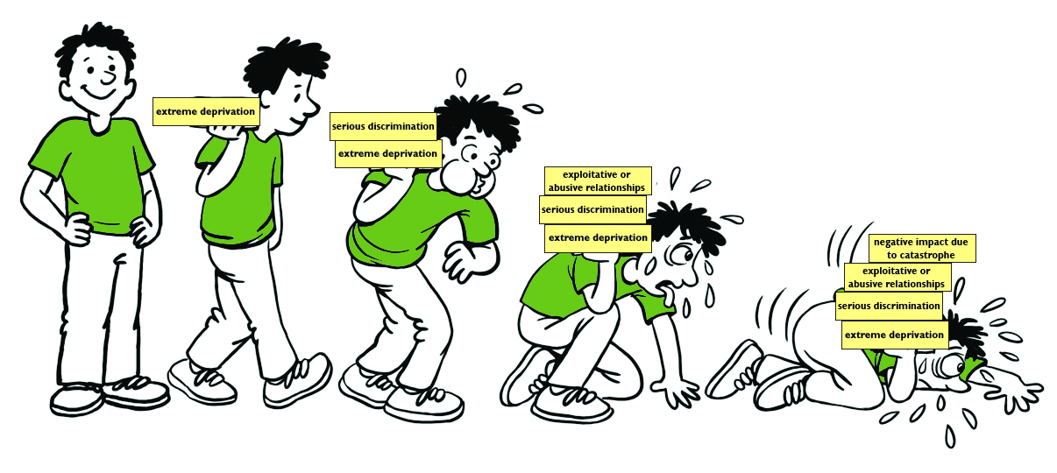
Figure 2: The more vulnerability factors children experience the more vulnerable they become.

Key considerations for working with the most vulnerable:
- Addressing WV’s special priority on the most vulnerable, means strategic programming for adolescents and youth affected by exploitation, abuse, extreme deprivation, serious discrimination or catastrophic events.
- It is critical to assess vulnerability factors based on gender to respond effectively to vulnerability factors affecting both males and females.
- Adolescent and youth programming can strengthen young people’s resilience and prevent increased vulnerability.
- Functional literacy, numeracy and other skills and competencies can all increase resilience and reduce the vulnerability of adolescents and youth.
- Strengthening assets and nurturing the spiritual development of young people will also increase resilience and reduce vulnerability.
- It is also important to address the underlying root cause issues leading to vulnerability for young people. The Child Protection and Advocacy project model aims to strengthen the child protection system and reduce vulnerability factors.

Questions for consideration:
- Who are the most vulnerable adolescents in the areas where you work
- Are there most vulnerable adolescents in places where you are not working?
- Have the young people, local champions and local partners identified who are the most vulnerable in their communities?
- Have you been able to identify and program to address the risk factors that are causing vulnerability?

Root cause analysis informing WV’s adolescent and youth programming
Responsive strategy and programming requires in-depth understanding of the challenges and root causes of issues which affect adolescents and youth in any given context. Root cause analysis will help identify appropriate project models to use. Whenever possible, WV’s role is to catalyse and support local partners, adolescents, youth and other community members who conduct root cause analysis. This will raise their awareness, mobilize local champions, and build the capacity of local partners and young people involved. The process can also be creative, fun and communicative – catalyzing local action.
Currently, there is no single root cause analysis tool available to investigate all the issues affecting adolescents and youth. However, a number of existing resources can be used to identify the root causes of the issues affecting these age groups:
- Use findings from the design process in WV’s Development Programme Approach: The first four steps of the Critical Path (wvdevelopment.org) involve a participatory community engagement process. The outcomes of these steps seek to mobilise all actors in the community and catalyse action around the well-being of children. Young people’s meaningful participation in each step and their inputs on decisions affecting their lives, is vital and can inform programming at both local and national level. This design process is not an isolated set of activities but rather the foundation for long-term engagement with young people throughout the life of the programme.
- Use findings from programme-level analyses: WV has developed Analysis, Design and Planning tools (ADAPTs) for health, child protection, and education. ADAPTs are toolkits that WV staff can use with local partners to analyse root causes. Findings from all three ADAPTs – health, education, and child protection – can provide valuable information about issues affecting adolescents and youth. For example the ADAPT for Health and Nutrition could indicate a high prevalence of early child marriage or female genital mutilation (FGM). The ADAPT for Child Protection could provide evidence of significant issues of gender-based violence or hazardous child labour. Young people can be actively involved in sharing their opinions on issues affecting them.
- Use findings, both quantitative and qualitative from using the Developmental Assets Profile.
- Review secondary data: Analysis of secondary data from the Demographic Health Surveys (DHS) (http://www.dhsprogram.com/), Multiple Indicator Cluster Surveys (MICS) (http://data.unicef.org/), as well as data and findings from LEAP programme assessments and evaluations can provide an important snapshot about the situation of adolescents and youth in any given context. In addition, the STEP data of registered children, aged 12 to 18 years old, can provide helpful data about issues affecting them.
In addition, there is an external toolkit that can be used (unless these assessments have already been done in your country and you can obtain a copy of the report and findings).
- The United States Agency for International Development (USAID) has a youth assessment toolkit: The Guide to Conducting Cross-Sectoral Youth Assessments provides a helpful framework and tools for designing and implementing youth assessments in developing countries. It is intended for use by assessment specialists and USAID staff interested in conducting a comprehensive cross-sectoral assessment of the assets and needs of youth. (http://www.equip123.net/docs/e3-CSYA.pdf)

Questions for consideration:
- Are we accountable to share our findings and data with young people and get their interpretation?
- How are we helping young people to be involved in identifying and understanding the key issues they believe need addressing within their community?
- Do we communicate findings in ways that give young people opportunities for discussion and action with local partners and the wider community?

Available project models for WV’s adolescent and youth programming
Five project models have been developed for adolescent and youth programming. These models are based on the theory of positive youth development and cover all the principles and essential elements included in this guidance. They also include foundational life skills to build competencies and essential life skills of young people.
Example of core curricula from IYF for adolescent and youth programming:
- Self confidence
- Respecting self and others
- Interpersonal skills
- Managing emotions
- Personal responsibility
- Positive attitude and self-motivation
- Conflict management
- Teamwork
- Communication
- Cooperation and teamwork
- Creative thinking
- Critical thinking and problem solving
- Decision making.
Strengthening Life Skills for Youth
International Youth Foundation

Each project model aims to mobilize and build the capacity of local partners and local champions as well as identifying or forming groups, called collective spaces, where young people can participate, grow, develop and engage with their communities.
Implementing these project models will help establish local partners, local champions and functioning groups of young people. Supplemental options (like lego blocks), such as additional curriculum, can then be used and implemented, building on existing capacities and resources.

Figure 3: Supplemental options can be used with any of the five available project models
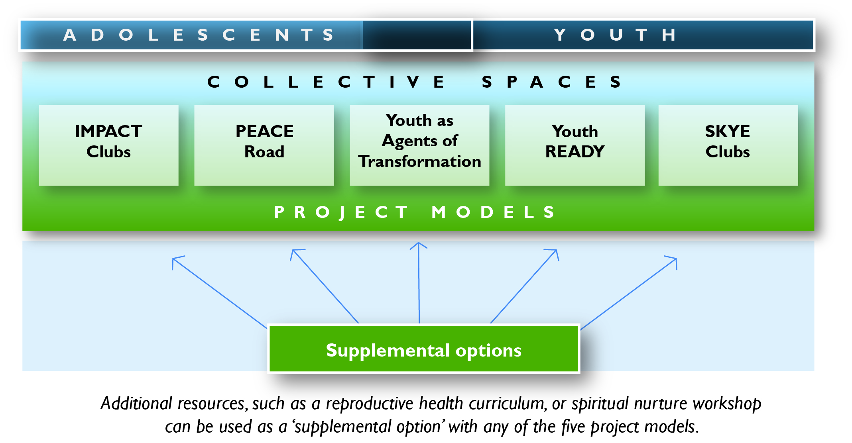
Questions for consideration:
- Which recommended project model is likely to be the best fit for your national office and why?
- Might other recommended project models also be a good fit for your national office? Why?
- How can the project model(s) you select be incorporated into a technical approach?
- What supplemental options (lego blocks) may be relevant for your national office context? How can they be combined with recommended project models?

Monitoring and evaluation for adolescent and youth programming
Based on the theory of positive youth development, the primary goal of all of WV’s adolescent and youth programming is ‘young people who are healthy, productive and fulfilled citizens’. This could also be called ‘developmental success’.
Full citizenship is seen
theologically as becoming a
citizen of the Kingdom of God, requiring a holistic, active and responsive journey that is reliant upon the individual, the community they are part of, and God to all contribute to change and identity.

‘Developmental success’ equates to a young person who is doing well, values their role, and is taking action in contributing to themselves; their families; their communities; and to the broader civil society. This concept is tightly linked to WV’s description of ‘children as agents of change’ in our approach of Transformational Development.
‘Developmental success’, for measurement purposes, combines an increase in thriving or positive behaviours and a reduction of risk behaviours. The outcomes measured in each project will depend on the specific approaches and how they are used and adapted in each context.
Thriving or positive behaviour includes:
- Academic commitment, success, and achievements
- Civic commitment/leadership/participation/change agent/responsible citizen
- Resilience/coping skills
- Maintaining/promoting healthy relationships
- Positive identity/sense of purpose
- Livelihood opportunities/economic capacity/viability
- Social-emotional/spiritual/psychosocial well-being.

Reduction in risk behaviour includes:
- Risky/early sexual practices
- Substance use/abuse
- Ability to withstand social pressures such as bullying, violence, gangs
(Internalizing/externalizing behaviours)

Many of these elements in developmental success are long-term and WV staff will not know if they have been achieved until young people are older and core developmental processes are established. Positive youth development identifies ‘leading indicators’ of development; experiences, opportunities and skills that, if developed, are likely to lead to long-term developmental success.
Two WV Theories of Change can be valuable reference documents as national offices develop their technical approaches:
- The Youth Empowerment and Livelihoods Theory of Change
- The Child Protection Theory of Change
These references may be particularly useful when developing the Pathways of Change.
Monitoring and evaluation (M&E) practices have great potential to support active learning and planning. Participatory M&E can involve young people in defining indicators of success; collecting and reviewing data, and reflecting, learning and planning with local partners.
Useful monitoring and evaluation data is timely and informative. There are five types of data that will prove helpful for project decision making. Data can also be used by young people and groups to reflect, learn, plan and develop themselves. The five types of measurement are shown in the diagram below.
Figure 4: Monitoring and evaluation framework for adolescent and youth programming
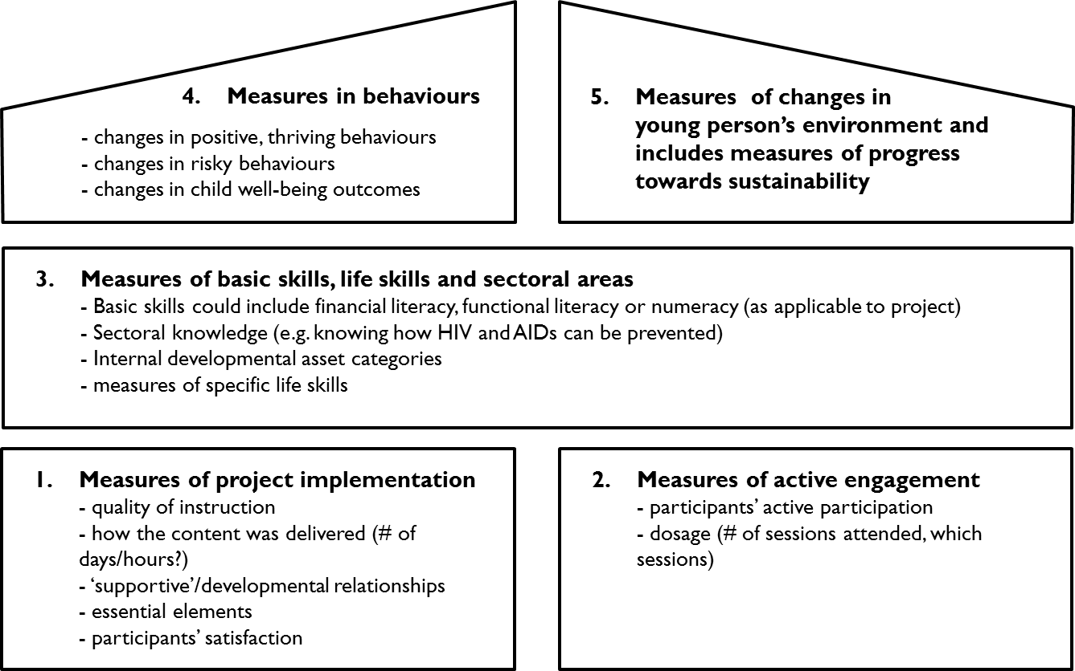

WV adolescent and youth measurements:
- Process indicators that measure project quality; including the quality of instruction, the delivery of content, the supportive relationships provided and the adaptation of the approach.
- Process indicators that measure the engagement of the direct beneficiaries involved in the project, including their ‘active participation’, and the number, length and attendance of the sessions.
- Intermediate outcome indicators that measure changes in internal developmental assets, basic skills, life skills, and knowledge and beliefs (For example, knowledge about how to protect oneself from HIV and correct understanding about how it is spread.)
- Long-term outcome indicators measure change in thriving behaviours and reduction of risky behaviours.
- Intermediate and long-term outcome indicators which measure change in the groups and movements where young people are participating. This includes changes in the contexts where young people live and external developmental assets, which focus on the web of supportive relationships and opportunities in their peer relationships, families, schools, and communities.

Questions for consideration:
- Discuss what productive and healthy citizens look like in your context. Are you effectively measuring these characteristics?
- How can we ensure that monitoring and evaluation with adolescents and youth maximizes their potential to collect data, to analyse it, to learn from it, to actively share and to make decisions and plans?

Facilitator competencies for WV’s adolescent and youth programming
The Integrated Competency Development (ICD) resources define the core competencies for local level staff implementing WV’s Development Programme Approach. WV staff play a vital role in promoting sustainability with local partners and local champions by raising awareness to identify passionate adults and partners, mobilizing them into action and strengthening their competencies to effectively engage with young people.
Additional key competencies needed by WV staff, local partners and local champions involved in adolescent and youth programming:
- Applying critical thinking and reflection –
This covers essential aspects of facilitating a transformational process, including the use of questions, curiosity and using simple analysis tools. (REL 01)
- Lead programme reflection and learning –
This competency covers action learning, coaching and ways to model reflective practice, that will be core to helping young people reflect and learn together. (REL 04)
- Build capacity using a coaching approach (CEP 05)
- Build and maintain relationship stakeholders (CEP 01)
- Facilitate engagement of children (CEP 03)
- Promote child-focused programming (CEP 06)
- Build child well-being collaborations (CEP 07)

A key role for WV is to build community awareness of the value of these champions; mobilizing, supporting, resourcing and building their capacity. Identifying and strengthening local partners and leaders who can support these champions will prove a far more sustainable strategy than WV staff directly supporting champions. A strategic role for WV is to help the community to identify and connect to those who can train and resource their champions.
The ICD resources help WV staff, local partners and local champions to assess their strengths and weaknesses so that key competencies can be identified and strengthened. At the heart of all of these competencies is the ability to ask strategic questions and help young people reflect, think and articulate their own responses.
The most important competency is Working with young people for positive change (SEP 006 – See Appendix B). This is the ability to effectively mobilise, facilitate and support young people to actively respond to issues that impact on their community and society
This competency includes four main elements:
- Model respect for others.
- Facilitate connections
- Nurture citizenship.
- Mobilise young people for positive change.
When literacy levels are low, facilitators need to be able to be able to communicate well and ensure the whole group can function effectively. They should also identify ways to strengthen functional literacy.

Questions for consideration:
- How are you training your staff to understand adolescents’ emotional needs?
- How do you identify and equip local partners and local champions from the community so that they can be facilitators of adolescent and youth initiatives?
- How are you challenging adult perceptions within local communities where adolescents are not seen as having the right to speak up or contribute to their community?
- How effective are you in helping young people to communicate in ways that strengthen their identity as positive change agents? What are the consequences of this?

Working with local partners in WV’s adolescent and youth programming
‘The luckiest young people all live in communities where the adults in their lives talk with each other and support each other, creating a web of influence that supports young people, even under great adversity.’
Search Institute
Developmental Assets: A Synthesis of the Scientific Research on Adolescent Development

The sustainability of adolescent and youth programming at community level is completely dependent on the commitment and capacities of local partners and local champions.
Potential local partners for adolescent and youth programming:
- Businesses or local private enterprise
- Schools (including after-school programs)
- School Management Committees
- Student Councils
- Parent Teacher Associations
- Children’s networks, clubs, societies, parliaments
- Churches
- Faith-based Organizations
- Child Protection Committees
- Local government units (like Parish or Village Development Committees)
- District government units
- Indigenous organizations
- Health clinics
- Other local community-based organizations
- Other non-governmental organizations

During Step 5 of the Critical Path, working groups are formed from local organisations and groups (local partners) who are seeking ways to work together on one or more of the community’s child well-being priorities.
When identifying appropriate partners, their level of interest, capacity and the type of adolescent and youth programming planned, all need consideration. For example, it would be valuable for a youth livelihoods project to identify partners such as local businesses. Partners need to show a passion for supporting young people in their growth and development.
Just as important as local partners are ‘local champions’ – people able to encourage, support and build positive relationships with young people. These ‘local champions’ may be members of a working group, and serve as volunteers, facilitators, coaches or mentors, with individuals or groups of young people.
Once partners are identified, WV can support them in becoming valid, credible partners who can contribute to child well-being within their community. This will require ensuring that the plans developed by young people are communicated with them, and ensuring that all partners have access to the planning processes within their communities.

Questions for consideration:
- Are young people engaged in the design process and seen as important stakeholders?
- Have you effectively mapped all potential local partners and champions for adolescent and youth work?
- How effectively do you build up, support and equip new local champions?
- Are you equipping young people with the skills to introduce themselves and present their vision and goals with adult groups and local partners?

Collective spaces in WV’s adolescent and youth programming
A ‘collective space’ is WV’s definition of any established gathering of young people that allows them to lead themselves and be clear in their ownership of the decisions, plans, actions and lessons that emerge. The key concept is ownership. This kind of ownership is fostered when the young people are actively engaged in choosing when, how and why they meet, and can take leadership. Engagement by young people in a ‘collective space’ must be voluntary. Types of ‘collective spaces’ include clubs, advisory groups, councils, or networks.
‘Collective spaces’ are starting points for the long-term engagement of young people. They build upon existing social capital and connection points for young people. They enable young people to feel safe and can provide strategic potential by enabling them to take as much of the lead as they are able, allowing increasing ownership.
It is important to note that at first effective spaces may not be fully led by young people. There is value and strength in ongoing developmental relationships between young people and adults. Our programming should promote healthy interdependence.
It is likely that adult support and coaching by local champions will be needed at first to help structure the group and its decisions. During the early stages, young people may be less experienced in working together and less confident in their experience. The task for local champions is to balance increasing levels of participation and depth of engagement by the young people, with the need to provide enough guidance and structure to enable the group to function and be motivated. It is appropriate for adults to serve as coaches and facilitators (not as teachers) and share decision-making authority.

Questions for consideration:
- Are there any existing ‘collective spaces’ within the community that could be built upon?
- What are the interests of existing groups – how can you build upon those?
- Are there any existing leaders and influencers of young people that you could work with as champions?
- How can you help each group to communicate and connect with other groups, thus building a stronger combined voice?
- How are you actively mapping groups and influencers within communities, to build connections between young people and adult groups?

Sustaining adolescent and youth programming
WV’s approach to sustainability is rooted in recognition that our contribution to a community’s journey will always be temporary. What happens during the journey will determine how long term and sustainable WV’s contribution will be.
Five ‘drivers’ of sustainability:
- Local ownership
- Partnering
- Transformed relationships
- Local and national level advocacy
- Household and family resilience.
World Vision’s Sustainability Drivers
World Vision International

WV defines sustainability as ‘the ability to maintain and improve upon the outcomes and goals achieved with external support after that support has ended’. The challenge is to ensure that positive changes experienced by young people are protected and sustained both during the life of the programme and for future generations. In every context where WV works, five key ‘drivers’ of sustainability need to be addressed to facilitate long-term sustained change. Each ‘driver’ must be considered during the development of strategy and programming for adolescents and youth.
In addition to these five ‘drivers’ of sustainability, several aspects of WV’s adolescent and youth programming promote long-term sustained change:
- WV can increase the potential for sustained change by thinking and planning strategically for adolescent and youth programming. Rather than small individual projects focused on different groups of young people, WV can work with local partners to implement holistic, integrated programming for many more targeted groups of young people within a given area.
- Linking groups of young people into networks, provides opportunities to learning together, challenging each other, and uniting together in local and national level advocacy.
- Local voluntary champions can encourage the sustained support of developmental relationships by adults. Sustainable programming should establish a structure that supports, encourages, recognises and provides incentives for these local champions. Young people may also volunteer, mentoring younger children and adolescents.
- Sustainability can be seen in healthy, productive young citizens, who have gained the skills, competencies, positive identity and commitment to serve their own communities.

Questions for consideration:
- How are you meeting each of these five ‘drivers’ of sustainability?
- How can you strengthen any areas that you are not fully meeting?
- Are you planning effectively for long-term sustainability in you work with young people?
- What support and structures are you providing for local champions, particularly for younger champions?

Local level advocacy in adolescent and youth programming
The Citizen Voice and Action (CVA) project model mobilises and equips citizens to monitor government services, and facilitates an advocacy methodology that results in the improvement of inadequate government-provided services. CVA is often used as a component of other projects to improve relevant government services for the well-being of children. Work is underway to identify effective ways for young people to meaningful participate in a CVA approach.
These approaches have great potential to provide young people opportunities to actively engage as citizens, but we must also ensure that we are not putting children in danger by helping them have ‘voice’. Supporting young people to be competent in selecting and using appropriate communications tools and approaches, coaching them and helping them to connect wisely and credibly with adults in their community are important to ensure we do no harm. The WV Child Protection Risk Assessment tool will assess potential risks with young people’s active participation. A youth-friendly component of Citizen Voice in Action is under development.
Spiritual nurture in adolescent and youth programming
Spiritual development is ‘an inward and outward journey of discovery for children as they grow in awareness of a sense of meaning and purpose in life; connect, empathise with and are influenced by others, especially parents and peers; begin to explore their understanding of God, and live out their spiritual beliefs and commitments in daily life.’
Spiritual nurture is the fostering of children’s ‘spiritual development’ throughout their life cycle stages, in the context of their whole being.

Principles to Guide Formation of National Policies on Spiritual Nurture of Children, 2010, WVI Board

Spiritual nurture is part of human development; it needs to be seen in the context of the whole person (spiritual, social, physical, cognitive). By recognising that all our actions, both intentional or unintentional, can influence the spiritual development of children, WV is committed to supporting spiritual nurture that contributes to children’s wellbeing. Spiritual Nurture of Children (SNC) can be integrated into WV’s adolescent and youth programming in ways that promote participation and personal development.
Research by WV reveals three dimensions in which young people discover God (their concept of a Divine Being) and live out their own spirituality. These three dimensions are:
1. Awareness: The spiritual journey of children begins with seeking to find the creator and maker of things such as the sun, moon, stars, rain, trees, seas, and themselves. They are driven by awe and amazement at the things they discover in their environment. Based on their personal encounters, children come to their own conclusion that there is a God.
2. Understanding: Over time, young people rediscover and define various aspects of God’s character. Role models and day-to-day experiences allow them to grow in their knowledge and understanding of God. Growing up in a safe and caring environment allows young people to arrive at a clearer awareness and understanding of the existence and character of God, which may eventually progress towards acknowledging the presence of God in their day-to-day lives.
3. Relationship: Young people enter into a life-changing relationship with God when they begin to seek and yearn for a committed and consistent interaction and experience with God. The growing relationship between themselves and God can move towards a deep maturing faith, leading young people to connect their identity with God, to recognize and seek out God’s purpose for their life, and share their experiences with others.

These three dimensions (awareness, understanding, relationship) can progress in stages throughout a young person’s development. However, all three dimensions can also happen at the same time.
Principles for integrating SNC into adolescent and youth programming:
- WV works with all young people in the community irrespective of religion or faith traditions.
- WV affirms the role of adolescents and youth as agents in their own spiritual and faith development. It respects their right to express their views, examine their beliefs and participate in decision making within the family and broader society.
Sample SNC approaches which can be integrated into programming:
- Exposure to nature and care for the environment
- Equipping opportunities for parents and caregivers
- Values formation
- Outreach and activities that enable young people to experience and live out acts of love and kindness
- Christian education
- Partnerships and relationship building.

- WV works alongside parents, caregivers and the community in creating spaces and opportunities for children to pursue their spiritual journey and experience God’s love. We intentionally work towards strengthening the family and building its capacity to provide spiritual nurture.
- WV is committed to seeking parental consent for all its activities including spiritual nurture.
- WV emphasizes shared accountability with partners in terms of the content, messages and approach of spiritual nurture materials, especially those funded using WV resources.

Questions for consideration:
- What steps have been taken to assess the spiritual needs of adolescents and youth?
- What tools or resources can you use to support the spiritual development of adolescents and youth in programming?
- Which partners can you work with in addressing the spiritual development of adolescents and youth?
- How effectively have you integrated the spiritual nurture of adolescents and youth into your programming?

Sponsorship and adolescent and youth programming
Sponsorship requirements and communications can be integrated into WV’s adolescent and youth programming in ways that promote participation and positive development.
Principles for integrating sponsorship activities into adolescent and youth programming:
- WV works alongside local partners, local champions and other community members, to engage young people in meaningful ways that build sustained capacity and ownership.
- Young people’s participation is regarded as an integral aspect of local programming efforts. (An integrated activity plan is developed for sponsorship communications by mapping all child participation activities.)
- WV promotes young people’s reflection so that they can grow and learn. Their feedback will help other young people and their community grow and learn.
- WV is mindful of, and responsive to, the context and the social development of young people.
These principles support and are reinforced by WV’s Programme Effectiveness Standards. In addition, WV staff, volunteers and local partners adhere to WV’s Guidelines and Principles for Child Participation.
The framework below depicts an action, reflection and learning cycle and the connections with sponsorship. Sponsorship activities, particularly those involving participation and communication, can be integrated into adolescent and youth programming. This framework can also be valuable in helping staff to ensure WV engagement in any project promotes life skills and positive development for young people.
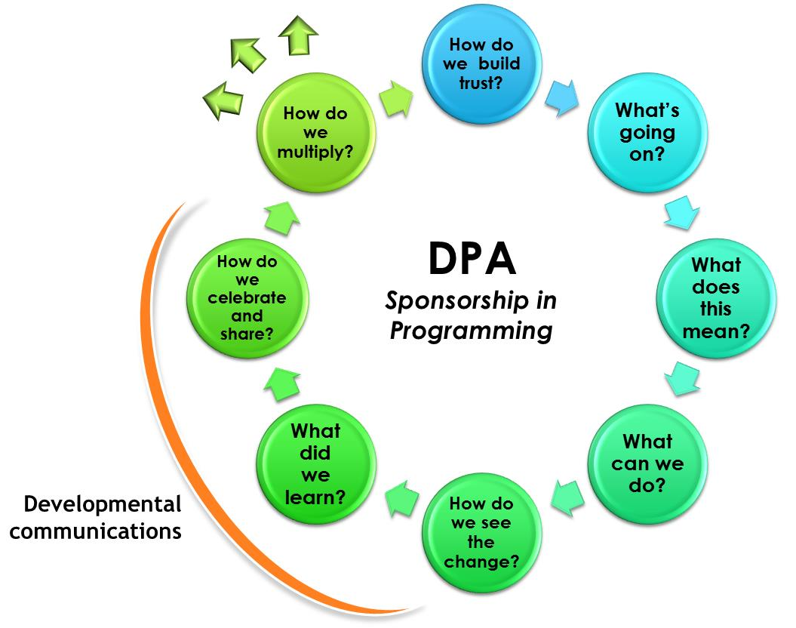

Questions for consideration:
- Do programme staff understand and know how to apply the above framework and links with sponsorship?
- Have sponsorship activities been integrated into programming activities planned with young people?

Appendix A – Resources
Child Participation Reference Guide
Child Protection Theory of Change
DAP Overview and Coordination Guide
Good Practices for Putting Development Programmes into Action is organised along the Critical Path. The Critical Path provides the backbone of the WV’s development programme approach.
Guidance Note on Measuring Child Well-being Target #1
Integrated Competency Development: Guidance, tools and resources available to support national offices in strengthening the competencies of local level teams implementing development programmes.
WV Guidelines on Child Participation: This document gives guidance on the minimum basic expectations to uphold the quality of child participation across World Vision.
Youth Empowerment and Livelihoods Theory of Change

Where do I find the project models? www.wvdevelopment.org

Resources for further reading:
Adolescence: A Time That Matters. (2002) The United Nations Children’s Fund (UNICEF).
Guiding Principles for International Youth Development. (2013) Alliance for International Youth Development, in partnership with Interaction.
Health for the World’s Adolescents: A Second Chance in the Second Decade. (2014) World Health Organization (WHO).
Investing When it Counts: Generating the Evidence Base for Policies and Programmes for Very Young Adolescents – Guide and Toolkit. (2006) The United Nations Population Fund (UNFPA) and Population Council.
Monitoring and Evaluating Life Skills for Youth Development: Volume 1 – The Guidelines. (2012) The Jacobs Foundation.
Positive Youth Development So Far. (2006) Search Institute Insights & Evidence, Vol. 3, No. 1.
Progress for Children: A Report Card on Adolescents. (2012) The United Nations Children’s Fund (UNICEF).
Promoting Positive Youth Development: Theoretical and Empirical Bases. (2005) White paper for the National Research Council; written by Richard M. Lerner, Institute for Applied Research in Youth Development.
State of Our World: Adolescence – Beyond the Stereotypes. (2011) The United Nations Children’s Fund (UNICEF).
State of the World’s Children: Adolescence – The Age of Opportunity. (2011) The United Nations Children’s Fund (UNICEF).
Strengthening Life Skills for Youth: A Practical Guide to Quality Programming. (2014) International Youth Foundation (IYF).
Yohalem N. & Wilson-Ahlstrom, A. (2010) Inside the Black Box: Assessing and Improving Quality in Youth Programs. American Journal of Community Psychology, 45:350-357.
Youth in Development: Realizing the Demographic Opportunity. (2012) United States Agency for International Development (USAID).

Appendix B – Competency for working with young people
COMPETENCY SEP 006: Work with young people for positive change

This competency describes the ability to effectively mobilise, facilitate and support young people so they are actively responsive to issues that impact their community and society. It describes how young people learn and grow as citizens with a positive, hopeful identity as they engage with adults in the community and within groups and networks of young people. This competency builds on the principles found in competency SEP 003 Facilitate the engagement of children. Working with children should naturally lead to working with young people for positive change.
ELEMENTS BEHAVIOURS
- Model respect for others | - Build relationships with young people in a way that models positive values.  - Provide an environment for young people that is physically and emotionally safe, especially for those who are most vulnerable.  - Model the principles of inclusion and tolerance by identifying and responding to factors that generate feelings of exclusion among young people.  - Promote basic human rights principles as appropriate in the context.  - Set and maintain appropriate boundaries in interactions with young people.
- Facilitate connection | - Interact positively with young people, individually and in groups.  - Facilitate affirmative relationships with young people in their peer groups.  - Create a space for young people’s engagement with adults in the community in a way that shapes positive and supportive partnerships.  - Generate opportunities for young people to participate in multiple areas of public life.  - Promote the use of multiple forms of expression and communication to help young people engage meaningfully in community life.  - Establish mechanisms for feedback from young people.
- Nurture citizenship | - Create formal and informal opportunities that build young people’s capacity to grow in citizenship.  - Engage young people as equal partners in decision-making processes.  - Support young people to develop problem solving and decision making skills through real-life and meaningful activities.  - Provide coaching at critical moments to encourage young people to question and reflect.  - Encourage young people to collaboratively plan, lead and reflect on group activities.  - Reward initiative using techniques based on encouragement, praise, and incentives that young people can relate to.  - Use a range of approaches to facilitate the participation of young people in the decision-making that affects their lives.
- Mobilise young people for positive change | - Engage young people in discussions on issues affecting others and broader struggles for social change.  - Use appropriate tools and methods to support young people in identifying and prioritising critical issues, opportunities and challenges they can act on.  - Respond to priorities articulated by young people by helping them find and enact creative and achievable solutions.  - Amplify young people’s voices by facilitating their participation in advocacy interventions.  - Facilitate cooperation between young people, parents and elders, to act jointly to resolve issues within their communities.

Adolescents and Youth Demographics: A Brief Overview (2012) United Nations.
Adolescence: A Time That Matters (2002) UNICEF.
Ibid.
Cunha, F., & Heckman, J. J. (2010). Investing in our young people (Working Paper No. 16201). Cambridge, MA: National Bureau of Economic Research. Retrieved from http://www.nber.org/papers/w16201
State of the World’s Children: Adolescence – The Age of Opportunity (2011) UNICEF.
Ibid.
http://undesadspd.org/Youth/FAQs.aspx
Damon, W. (2004) What is Positive Youth Development? Annals of the American Academy of Political and Social Science, 591, 13-24.
Durlak, J.A. & DuPre, E. (2008) Implementation Matters: A Review of Research on the Influence of Implementation on Program Outcomes and the Factors Affecting Implementation. American Journal of Community Psychology. 41:327-350.
Based on Community Programs to Promote Youth Development (2002) National Research Council.
Li, J., & Julian, M. M. (2012). Developmental relationships as the active ingredient: A unifying working hypothesis of “what works” across intervention settings. American Journal of Orthopsychiatry, 82(2), 157–166. doi:10.1111/j.1939- 0025.2012.01151.x
http://www.search-institute.org/sites/default/files/a/Dev-Relationships-Framework.pdf
Reference tab, wvdevelopment.org.
State of the World’s Children: Adolescence (2011) UNICEF.
wvdevelopment.org
Click on Programming Tools tab, and then click on Project Models and ADAPTs tab, wvdevelopment.org.
Lerner, R. (2004) Promoting Positive Youth Development: Theoretical and Empirical Bases. White paper for Workshop on the Science of Adolescent health and Development, national Research Council, Washington, DC, September 9, 2005.
The Developmental Assets Profile (DAP) focuses on young people’s experiences of these ‘leading indicators’, which are associated with increased thriving and positive behaviour and reduced risk behaviour.
http://wvylig.groupsite.com/uploads/files/x/000/0a8/a89/World%20Visions%20Youth%20Livelihood%20and%20Empowerment%20Theory%20of%20Change.pdf?1402387657
Integrated Competency Development (ICD) tab, wvdevelopment.org.
Good Practices for Putting Development Programmes into Action (2011) World Vision International, wvdevelopment.org.
Reference Materials tab, wvdevelopment.org.
See Integrated Competency Development (ICD) tab, wvdevelopment.org.

